Kindergarten Choice Board-June 1
Remember having your child read or reading to them is very beneficial!!!
Rainbow Writing  Write a list of your No-Excuse words, but this time use a different color for each letter in the word!  What  The | Five Senses  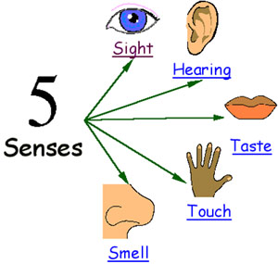Choose a food. Write a sentence for each; What does it taste like? What does it feel like? What does it smell like? What does it look like? When you bite it what does it sound like? | Nature Pattern Time  Use a stick and draw a pattern in the dirt that has a core with 3 shapes...repeat the core 3 times. Use 3 different items(sticks, rocks, leaves) and make a pattern on the ground using these items.  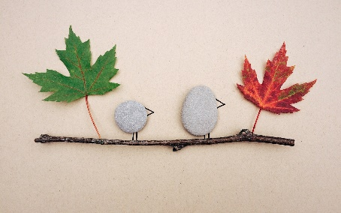
Mrs. Madore  French Flora activity for K-4 students.  Go to Level 2, module 3  Listen to the book named  “My house, Ma maison”  Read about items in your house. Then listen and sing the song ma maison. https://flora.nbed.nb.ca | Part/Part Whole  Let’s use the whole of 11 this week. Make up 2 stories about being at a restaurant, 1 story about being on a farm and then you choose your own setting for another story. If you have sidewalk chalk use it to draw your part/part/whole mat and use things you can find outside for your manips!  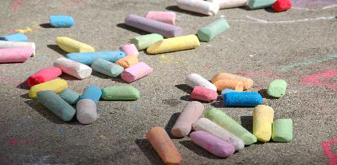 | Rhyming Time  Gather a set of7 or 8 tokens(any small items). The first player says a work and the partner has to say a word that rhymes with that word. Continue rhyming until a player can’t think of a word to rhyme. The person that rhymed last gets a token. Start again with a new word and play until all tokens are gone. Player with most tokens is the winner!

